Scottish Association of Histotechnology
  - Issue 2 Autumn 2022
sAVE THE DATE!!!
Follwing on from the presentation on Plastics and sustainability by Charlotte Hale, V & A Dundee Curator. The exhibition is due to open on Saturday 29th October 2022 with tickets on sale now.
For more information:
https://www.vam.ac.uk/dundee/exhibitions/plastic
Modern rotary microtome

Welcome
Delegates and fellow Science enthusiasts,
Following the successful 43rd Scientific Meeting in Dundee at Queens Hotel, we can now introduce our Second Association of Histotechnology (SAH) newsletter. The Committee and I would like to express our thanks not only to our speakers - Dr Oliver Rupar, Charlotte Hale, Nicola Robson, Professor Linda Bauld and Fiona Young – but to all in attendance and those who expressed interest in the event. I hope that you were able to attend in person, however I am conscious that we are still emerging from the Covid-19 pandemic and so all presentations are available on the website should you have missed out in June. I should mention, the exception to this is Charlotte Hales presentation -Plastic: Remaking our world which was a specialised preview for our delegates on the day. This is actually due to be an exhibition at the V&A in Dundee, running from October 29th through to early 2023.
As a Committee we will now start the process for organising next years’ Scientific Meeting and with that would like to introduce Jiya Matthew joining us whilst she is on her final years in her Biomedical Science Degree. It is our hope to have more of a presence on social media going forward and particularly if you feel up to the challenge of running social media accounts with fun and inspiring posts we would love to hear from you!
And with that, I would again like to thank you for your continued support and feedback which allows us to organise and host these events. We will release a further newsletter with more information around the next event. Until then I hope you can all enjoy the shift of season and dive into the autumn/winter festivities.
Who are we?
The SAH formed in 1997 with the 4 main aims of holding symposia to enable presentation of scientific papers and lectures, to provide a forum for discussion and to encourage research and a high standard of competence within the profession.

join our committee!!
There are still positions available for anyone interested in joining the SAH Committee which includes named roles and support members. Please do email one of the Committee Members or the generic email address [sah.generic@lanarkshire.scot.nhs.uk] if you would like some more information.

Meet the committee
Q: Name and occupation
A: Jiya Mathew, 4th year student at Robert Gordon’s University studying Applied Biomedical Science

Q: Why did you choose biomedical science?
A: When I was first researching on what to do for uni, I came across Biomedical science, to be honest I had no idea what that was and what they did but after reading a little into I realised I liked the sound of it, so I kind of found myself falling into a research rabbit hole on BMS, learning a lot about the different disciplines and how a lot of diagnosis are based on results provided by laboratory services etc. I also really enjoyed microbiology at school so that also contributed to my decision.

Q: What’s your least favorite degree topic?
A: I didn’t really like histology/cytology up until I went on placement, I think this has to do with how it mostly covered dyes, dyeing, pigments and minerals etc. I feel like I only found out how much more there is to histology after I did my placement where I got to cut tissue samples and embed them myself. Due to covid, we didn't get to do any lab practicals at uni so we didn't get to put into practice the theory we learned which for me is really important as that's how I learn best, so being able to apply what I learned during my placement made me realise how much more there is to histology than just dyes.

Q: If you could have any job, what would your ideal job be?
A: This is a bit random but one of those huge mining truck drivers, I saw it in TV one time and thought it would be really cool. If not then a pilot, I've always wanted to be one when I was younger and would could crazy whenever we took a plane to go anywhere, but I'm also terrified of heights so I doubt I'll make it far if I tried to become one.

Q: Finally – pineapple on pizza? Yes or hell no?
A: I actually don't mind pineapples on a pizza, I wouldn't say that it's my favourite or go-to pizza but I wouldn't not eat it if it was the only option.
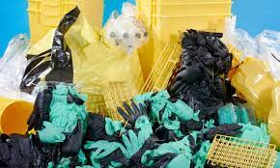
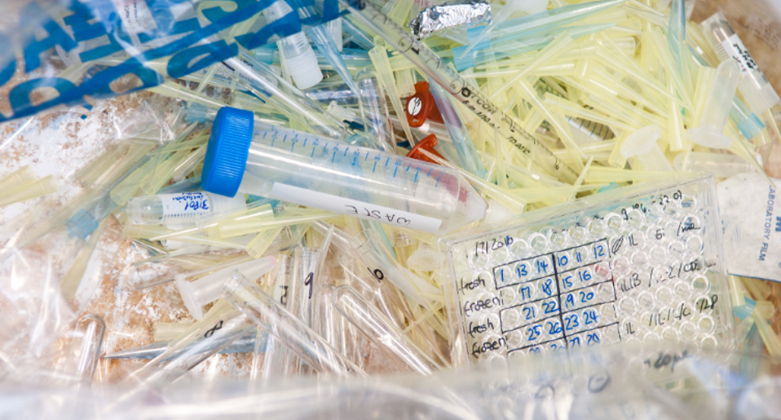
LAB PLASTICS – SURVERY USERS REQUIRED
Following on from the excellent group discussion at the 43rd Scientific Meeting, around the topic of lab plastic use and sustainability, the SAH committee thought it would be a good follow-up activity to produce and circualte a survery on lab pastic use.
Charlotte Hale, during her talk, gave data for medical plastic use in a surgery department as collated by Healthcare without Harm. The SAH thinks this could a good opproutinity to do something similar within the Scottish pathology labs. Maybe a diary to be kept for a period of 10 days, listing the types and amounts fo disposable single use plastics used. If you would like to represent your lab in this activity, please email tammy.piper@ed.ac.uk
Puzzle corner - ANAGRAMS  - Carrie Clot - Alain Ox Thyme - Aunt Mont - Catt Poswatters - Coach Dalilo - Belinda Duonitty - Rab Weshuff - Eddy Halfrome - Cuban Leila - Cher Faginfests  Clue: reagents (NB: Answers to Issue 1 anagrams on SAH website) | Contact us!!  Email: sah.generic@lanarkshire.scot.nhs.uk  Website: www.saht.org.uk  Twitter: @ScottishAssoci1  Instagram: scottishassociationhistotech  Facebook: @www.saht.org.uk
Recipient Name
Street Address
City, ST ZIP Code

