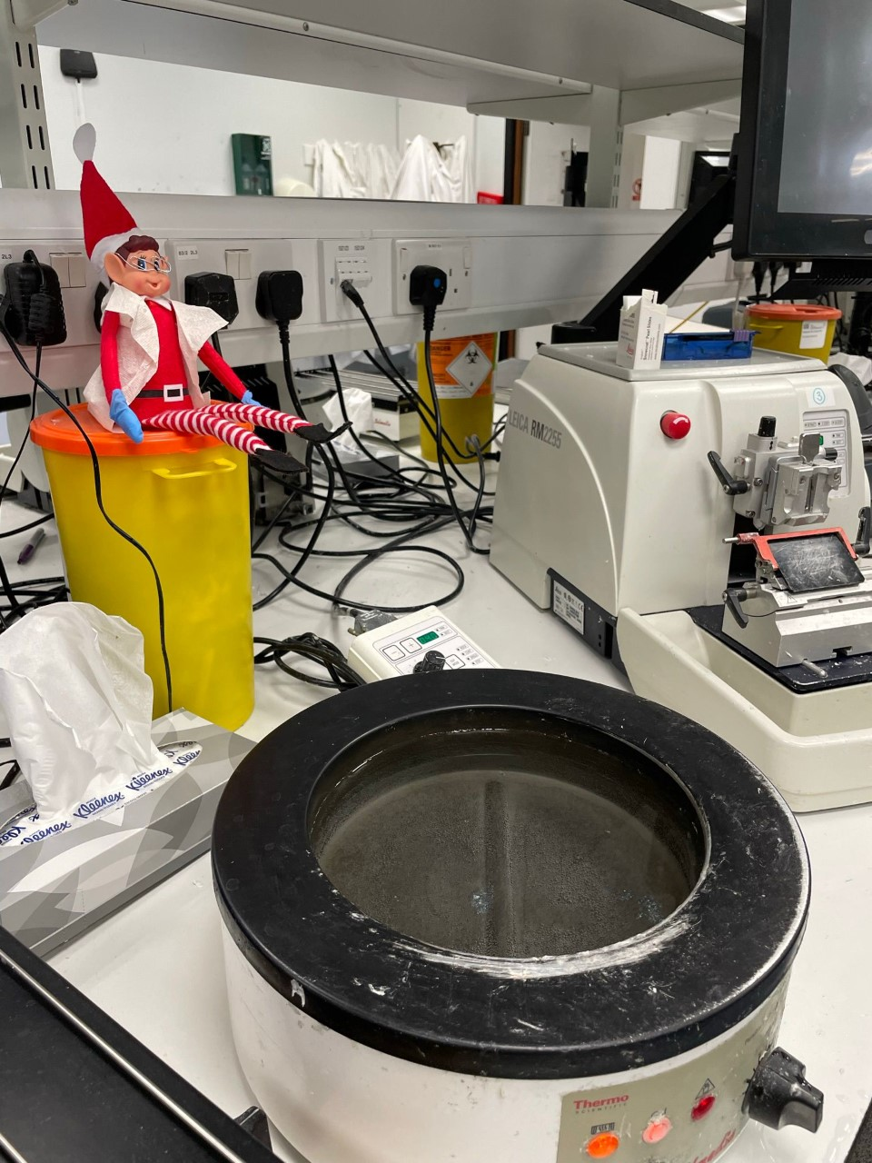
Scottish Association of Histotechnology
  - Issue 3 Winter 2022
sAVE THE DATE!!!
We are pleased to confirm the date of the 44th Scineitific Meeting will be Friday 9th June 2023 at the Golden Jubilkee Conference Cnetre, Clydebank. Watch this space for more details!!
Modern rotary microtome

Welcome
Delegates and fellow Science enthusiasts,
Welcome all to our Third Association of Histotechnology (SAH) newsletter. The Committee and I would like to now let you know details of our 44th Scientific Meeting which will be held in June 2023! As a Committee we are now organising next years’ Scientific Meeting and are currently securing our speakers for the event.
As last time, there are still positions available for anyone interested in joining the SAH Committee which includes named roles and support members. Please do email one of the Committee Members or the generic email address [sah.generic@lanarkshire.scot.nhs.uk] if you would like some more information. It is our hope to have more of a presence on social media going forward and particularly if you feel up to the challenge of running social media accounts with fun and inspiring posts we would love to hear from you!
And with that, I would again like to thank you for your continued support and feedback which allows us to organise and host these events. We would like to warmly wish you a fantastic Christmas season and hope to hear more feedback and suggestions in the New Year.

A DAY IN THE LIFE OF – SPECIAL BIOMEDICAL SCIENTIST
Being a Specialist Biomedical Scientist, my day to day often varies throughout the week between general specialist duties and my more specialised duties. The specialised duties I perform on top of my role includes; Co-Running the Electron Microscopy Services at NHS Tayside/Lothian, COSHH Assessments, Co-Running the PDL1 Autostaining Service and Auditing and Mentoring. I will outline a general day in my role for this segment.
- Work begins often at 8 or 9am, the early rota is 8am-4pm where embedding is the priority for the first hour. If it is a 9am start then collecting the urgent blocks from the embedders is the priority to get these cut and on the staining machine.
- Rota’d duties then generally begin around 10-10:30am. These include; Dissection Assistant, DRIF (decal/renal/immunofluorescence/frozen sectioning), Special Stains, Duty BMS for IQC and micromanagement of the lab and Immunocytochemistry.
- Each rota’d duty has their own set of specific steps, however if no rota’d job is given then we are embedding/Microtomy.
- Either I would relieve an early morning embedder or would consistently cut loads of 30 blocks at a time throughout the rest of the day.
- 4pm is the latest sections can be stained on the H&E autostainer so I would then for the last hour of the day assist the Duty BMS with IQC to get cases out to pathologists for reporting.

Meet the committee
Q: Name and occupation
A: Tammy Piper, Tissue Bank Manager, Biomarkers & Companion Diagnostics Group, Edinburgh Cancer Research Centre

Q: Why did you choose biomedical science?
A: I actually fell into becoming a BMS after graduation. I completed a degree in Marine Biology and was looking for more lab experience. I applied for a MLA job in the cytology lab and was offered a trainee BMS position instead. One MSC, logbook and state registration later, I landed a job as a BMS 1 in the tissue bank and the rest is history as they say.

Q: What’s your least favorite part of the job?
A: Paperwork. Lots and lots of paperwork. We bank tissue for patients in clinical trials and have to document everything we do. I spend most days completing reports and databases for tracking samples. However there are periods of time when I get to do some microscopy and image analysis which is my favorite parts of the job

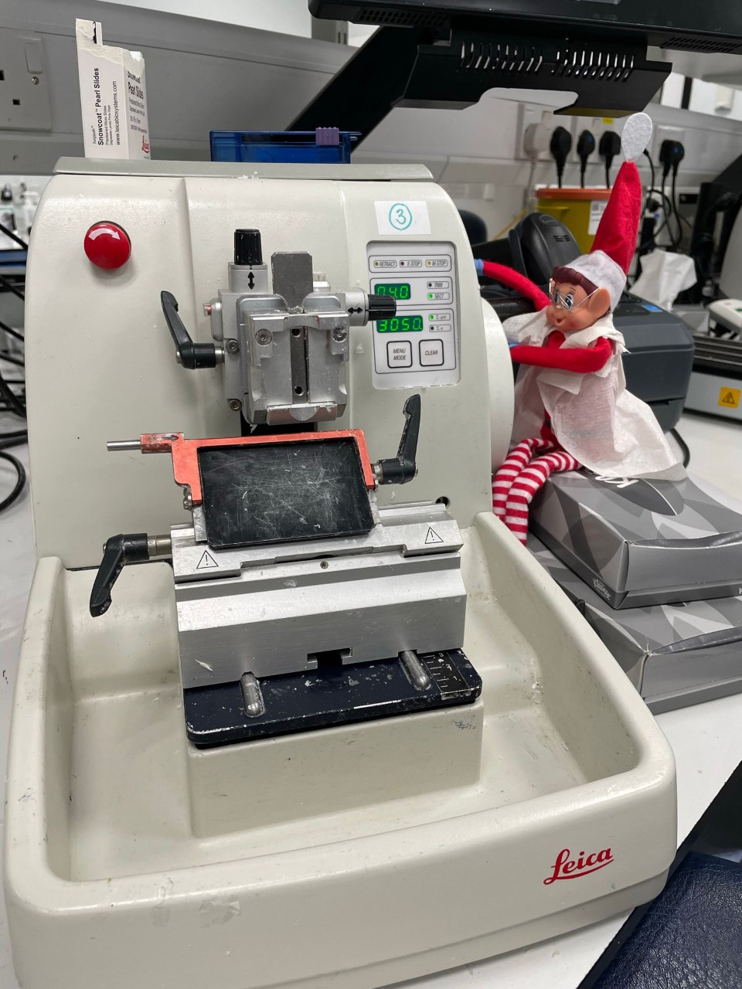
Q: If you could have any job, what would your ideal job be?
A: Either a sign language interpreter or a professional knitter.

Q: Finally – pineapple on pizza? Yes or hell no?
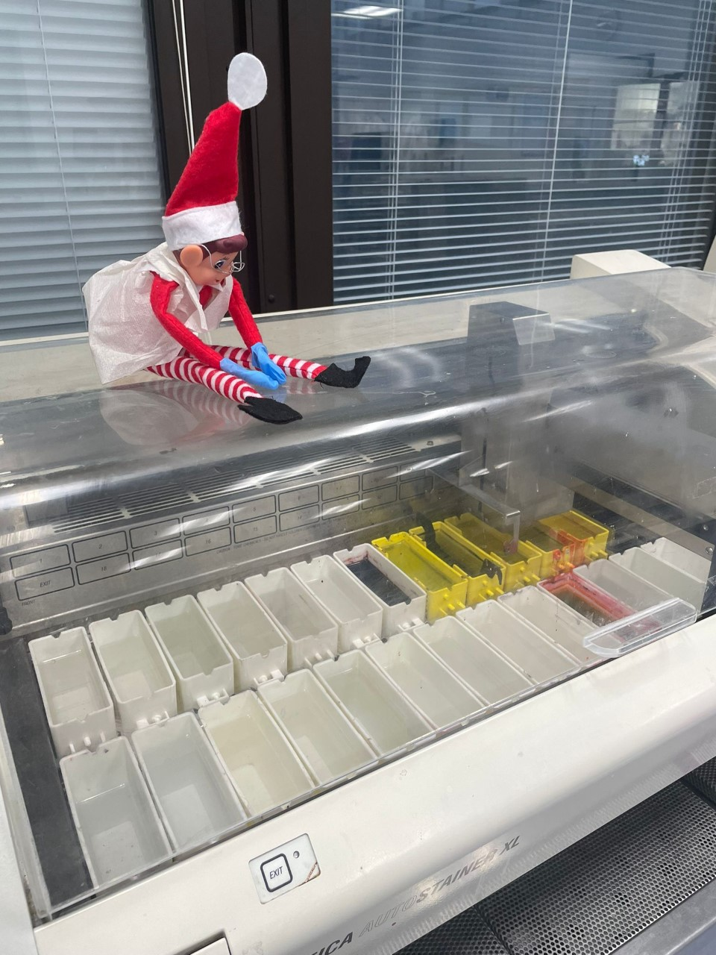
A: Only with ham, not with chicken.
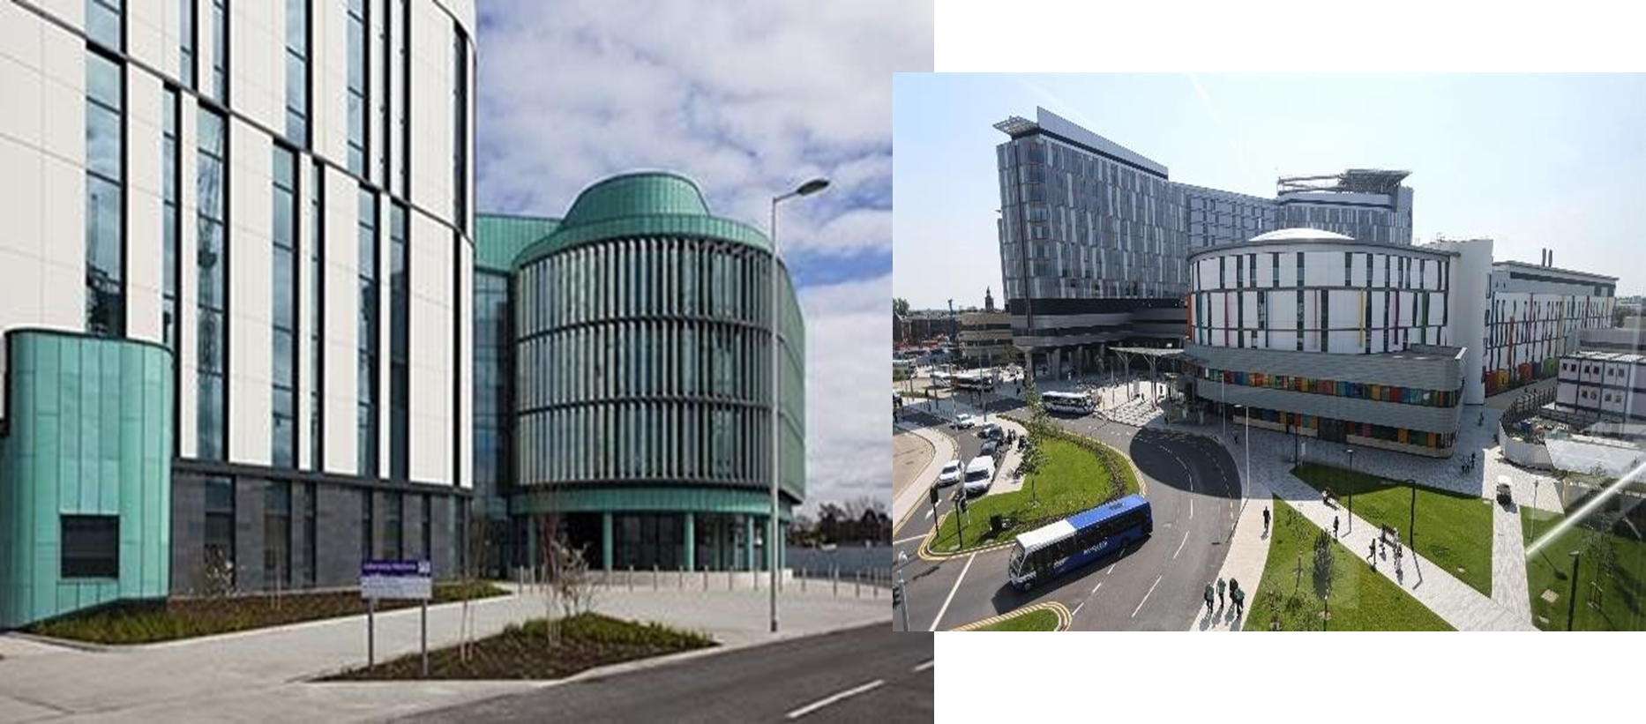
BIOrepository AT GGC – ALAN KENNEDY
GG&C Biorepository was set-up in early 2002 between Greater Glasgow Health Board and the then North Glasgow University Trust. The Biorepository role is supplying human material for medical research within a ethical and legal framework.
Here I carry out several research projects, but my main work is the STAR project. This project as part of the overall livinglab network, involves identifying cancer, cardiovascular and inflammatory disease samples and transforming them into an important biological and medical analysis resource using tempo-seq genomic and other testing procedures. This work is currently being used with mesothelioma cases, but has a wide range of different applications.
If you would like to hear more about the Biorepository or the STAR project please email alan.kennedy6@ggc.scot.nhs.uk.
Puzzle corner - ANAGRAMS  - actus nasal - liesmotet - garlicssenor - genuskittyruff - epicmine - erneiede - girdlehies - awkfelons - angstmockxis - metamipon  Clue: reagents (NB: Answers to Issue 1 anagrams on SAH website) | Contact us!!  Email: sah.generic@lanarkshire.scot.nhs.uk  Website: www.saht.org.uk  Twitter: @ScottishAssoci1  Instagram: scottishassociationhistotech  Facebook: @www.saht.org.uk
Recipient Name
Street Address
City, ST ZIP Code

