Scottish Association of Histotechnology
  - Issue 1 Spring 2022
sAVE THE DATE!!!
The 43rd Scientific meeting of the SAH will be held on Friday 10th June 2022 at The Queen’s Hotel Dundee. Our first in-person meeting since 2019 – be sure not to miss the exciting line-up including a presentation by Professor Linda Bauld, of BBC News Covid update fame!
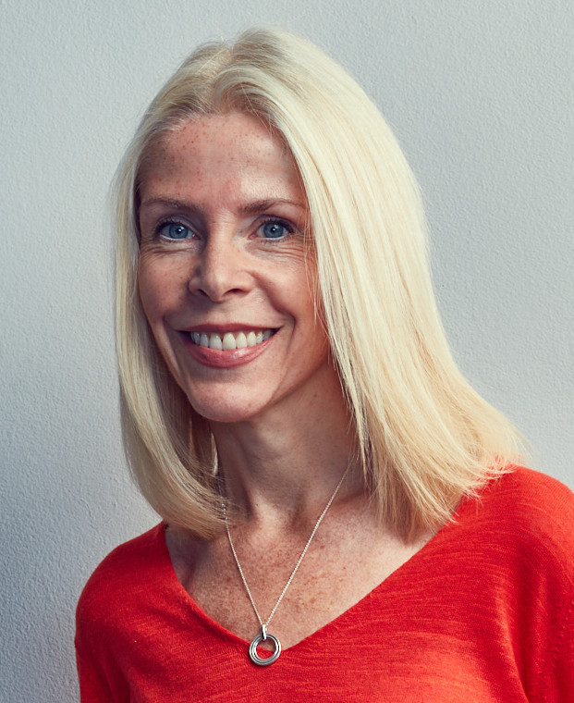
Modern rotary microtome

Welcome
Delegates and fellow Biomedical Scientist enthusiasts!
Welcome to the first Scottish Association for Histotechnology (SAH) newsletter. The Committee and I hope you enjoy this new venture and that it helps to get to know all those involved in the Committee a bit better. This is also a new way of informing you what will be coming up in future meetings and a platform for you to let us know what you would be interested in seeing/experiencing in future events.
As Chair of the Committee, I would like to thank you for your ongoing support and interest in our events despite a tough couple of years in the Covid19 Pandemic. We hope to see you at this year’s event in Dundee on June 10th.

Who are we?
The SAH formed in 1997 with the 4 main aims of holding symposia to enable presentation of scientific papers and lectures, to provide a forum for discussion and to encourage research and a high standard of competence within the profession.

Meet the committee
Q: Name and committee role
A: Hi! My name is Alan Kennedy and I am the treasurer and IT secretary for the Scottish association of histotechnology committee

Q: How long have you worked in pathology?
A: I have worked in pathology since 2007, so that would make it 15 years now, working in several different labs, including Aberdeen, Monklands and Glasgow Biorepository laboratories, so lots of experience of different places.

Q: What’s your least favorite lab task?
A: Well this is a tricky question here, I would say I am not a huge fan of Quality work as can be repetitive at times but I know how important it is. While my favorite areas are I.T and doing research from my MSc project to now the Biorepository Living lab STAR project as well as work with the SAH. I however do enjoy a variety of different task and always approach work with enthusiasm and open mind on learning more.

Q: If you didn’t work in a lab, what would your ideal job be?
A: Well there are several jobs I would like, but I am a big I.T fan and did do this as a side job in 2020 when covid was at its height. I helped the Scottish tech army during the pandemic with work that eventually led to helping the Scottish government with covid data gathering and I still work there when I can every so often. However I do enjoy pathology work that I do and always open to variety of new areas, with new areas like digital and AI in the future.

Q: Finally – pineapple on pizza? Yes or hell no?
A: Well this is a certainly a yes from myself, being my favourite pizza is Hawaiian, much to some of my colleagues disgust, even received a pineapple related T-shirt as a leaving gift from some of my colleagues previously as well. So can say Ham and pineapple all the way.

Call our for committee members
Microtome (C. Reichert, Vienna, 1905–1915)
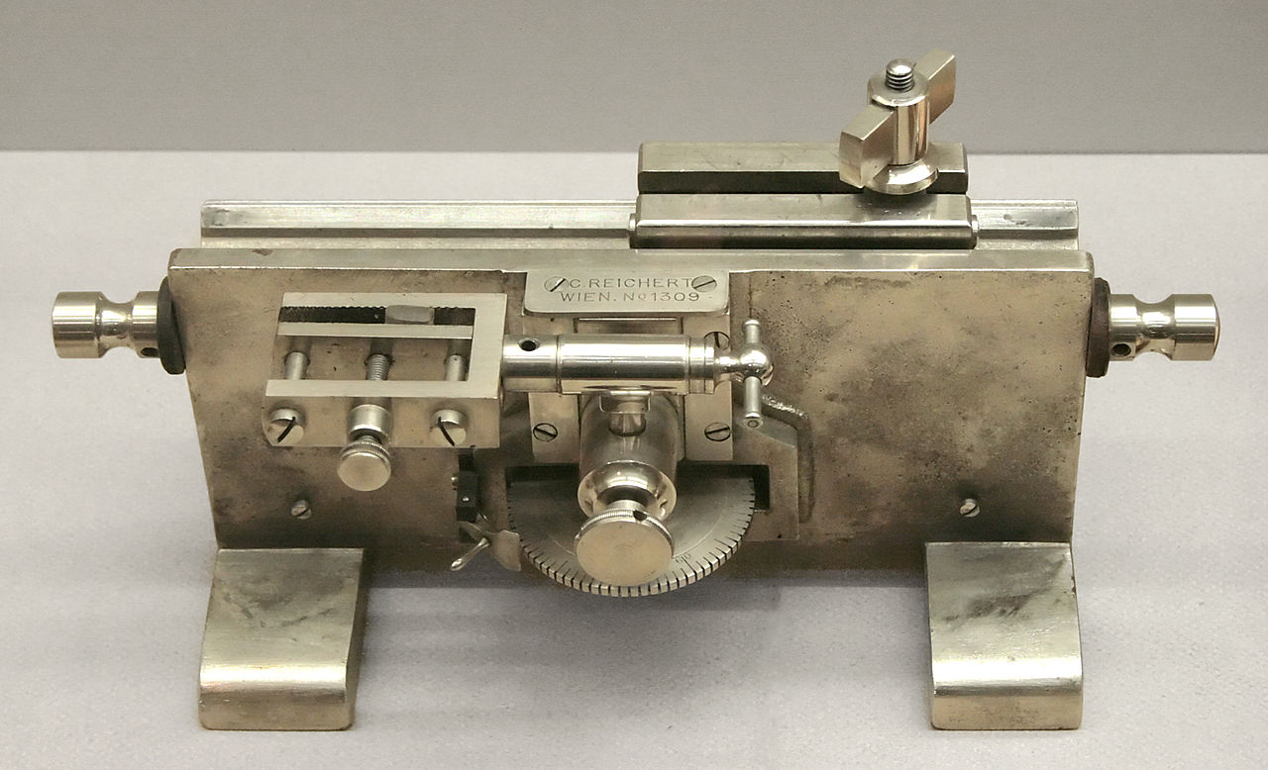
Due to retirement and maternity, we are advertising for new committee members. We have expanded the committee roles to include two new positions of student rep and social media co-ordinator plus we’re looking for extra members to help in more general ways. Get in touch if interested! A great way to get CPD points, boost your CV and make contacts!
The Microtome
From the Greek Greek mikros, meaning "small", and temnein, meaning "to cut", a staple found in all histology labs.
The first microtome used to cut this sections for light microscopy was invented in 1770 and looked very different to the rotary microtomes of today, being more cylinder shaped but still using a hand crank. These were invented to aid with sectioning material for the new trend in light microscopy, sweeping across Europe.
Now there are a variety of microtomes including ultramicrotome, laser, saw and vibrating microtomes with interchangeable blades made from steel, diamond or glass with different profiles such as wedge, concave or chisel.

A day in the lab with…..A tissue bank manager
A typical day starts with me checking in with my colleages to see how the current projects progressing. After replying to emails I may then spend my morning providing costings for upcoming collaborations convering sample receipt, H&E production, DNA/RNA extraction and shipping. I also have reports to generate for the various project management groups, updating them on the progress of the sample collection from sites and I also produce a montly report on all projects for our research manager. There is a lot of admin involved in handling human tissues for trials and shipping internationally. Other duties include QA checking our lab work such as reviewing areas of tumour selected for processing or data cleaning the digital image analysis research we run for our clincial trials. I do use a LOT of excel. Occasionally I get back to the bench and use my microscope to tumour mark H&E slides or do some IHC scoring.
Puzzle corner - ANAGRAMS  - Ratio unseat - Merci moot - Beat wrath - Crop sores - Act story - Beer medd - Sergeant - Comic spore - Cop refs - Acid nobel  Clue: Lab equipment | Contact us!!  Email: sah.generic@lanarkshire.scot.nhs.uk  Website: www.saht.org.uk  Twitter: @ScottishAssoci1  Instagram: scottishassociationhistotech  Facebook: @www.saht.org.uk
Recipient Name
Street Address
City, ST ZIP Code

