Scottish Association of Histotechnology
  - Issue 5 Summer 2023
LUNCH AND LEARN
Unfortunately due to committtee avilabiltiy constraints the first SAH Lunch and Learn will be post-poned until the New Year.
Modern rotary microtome

Welcome Delegates and fellow Science enthusiasts,
Welcome all to another Association of Histotechnology (SAH) newsletter. The Committee and I would like to express our thanks to those who attended our 44th Scientific Meeting which was held on June 9th 2023 at the Golden Jubilee Hotel in Clydebank.

Updating from our call for committee members last time, we would like to extend a warm and grateful welcome to Hannah Morgan and Bethany Gregor who have expressed interest in the committee. There are still positions available, ideally the committee would have up to 9 members which would allow for substitutions should one of us not be able to attend an event. It is important going forward that we establish numbers in the committee to continue doing these events. For anyone interested in joining the SAH Committee which includes named roles and support members. Please do email one of the Committee Members or the generic email address [sah.generic@lanarkshire.scot.nhs.uk] if you would like some more information.

And with that, I would again like to thank you for your continued support and feedback which allows us to organise and host these events.
Best Wishes,

SCIENCE ARTICLE – the trouble with tils
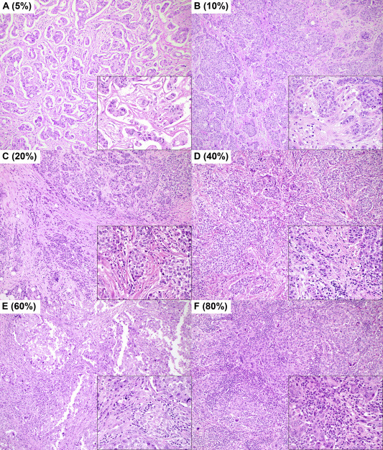
TILS or Tumour Infiltrating Lymphocytes have generated a buzz as the next new biomarker. There is growing evidence that assessing stromal TILS (sTILS) may indicate a patient’s tumour response to chemotherapy. The idea is that ‘immune hot’ tumours i.e. tumours with high levels of sTILS might actually not need chemotherapy as the patient’s own immune system could be activated to deal with any residual tumour cells. In Europe, there are breast cancer Clinical trials where patients are randomised based on sTILS assessment of the diagnostic H&E (1) All of this sounds very exciting but there are challenges to overcome before sTILS could be used as a biomarker. Firstly, counting sTILS is all well and good but what should the cut-off be for clinical use? Similar to Ki-67, there has yet to be definitive guidance on how many sTILS are sufficient for a ‘sTILS HIGH’ result. One Swedish study applied cut offs of <1%, 1-9%, 10-49%, 50-74% and 75%+ (2). Another study used <10% = LOW, 11-59%= MEDIUM and 60%<=HIGH.
Secondly, what would be the clinical relevance of having a sTILS HIGH result for patient treatment? Would it indicate a patient could skip the non-beneficial chemotherapy and undergo surveillance post-surgery instead? Or, would they be offered new and as of yet to be patented drugs that target immune hot tumours?
Finally, what if the make-up of the lymphocytes is important as well? The International TILS working group (https://www.tilsinbreastcancer.org/ ) have been at the forefront of TILS research trying to overcome these challenges and have a very informative website where you can learn everything you ever wanted to know about sTILS and assessing them.
References:
- Tumour infiltrating lymphocytes in breast cancer: increasing clinical relevance; Saldago R, ; December 7, 2017; http://dx.doi.org/10.1016/S1470-2045(17)30905-1
- Immune Infiltrate in the Primary Tumor Predicts Effect ofAdjuvant Radiotherapy in Breast Cancer; Results from the Randomized SweBCG91RT Trial; Stenmark Tullberg, A. et al Clin Cancer Res; 27(3) February 1, 2021
QUIZ WINNERS – CROSS MONKS!!
Congratulations to the Cross Monks team for winning the 2nd SAH Scientific meeting quiz.
No trophy, just fame and glory and the chacne to defend their title at next years Scientific meeting! Well done!!

Meet the committee – NEW MEMBER!!!
Q: Name and occupation
A: Beth Gregor-Quinn, Biomedical Scientist, Pathology, University Hospital Monklands.

Q: How long have you worked in pathology?
A: Just over 3 years, during which I have completed Top-Up modules at university to progress to my role as a Biomedical Scientist.

Q: What’s your least favourite lab task?
A: I think I’d have to say loading small biopsies.

Q: If you didn’t work in a lab, what would your ideal job be?
A: I’ve worked in a bridal shop since I was at university so I would love to do it full time if I didn’t work in the lab. I love the excitement and chatting to brides and their families!

Q: Finally – pineapple on pizza? Yes or hell no?
A: Yes, absolutely! One of my favourite toppings.
Puzzle corner - ANAGRAMS  - Motleypsych - Quamsous - Curloman - lampas - Ameliesloth - Laganmint - Carlyfoot - Codyinsect - heleliptia - Eddnitiric  Clue: cell (NB: Answers to Issue 4 anagrams on SAH website) | Contact us!!  Email: sah.generic@lanarkshire.scot.nhs.uk  Website: www.saht.org.uk  Twitter: @ScottishAssoci1  Instagram: scottishassociationhistotech  Facebook: @www.saht.org.uk
Recipient Name
Street Address
City, ST ZIP Code

