Scottish Association of Histotechnology
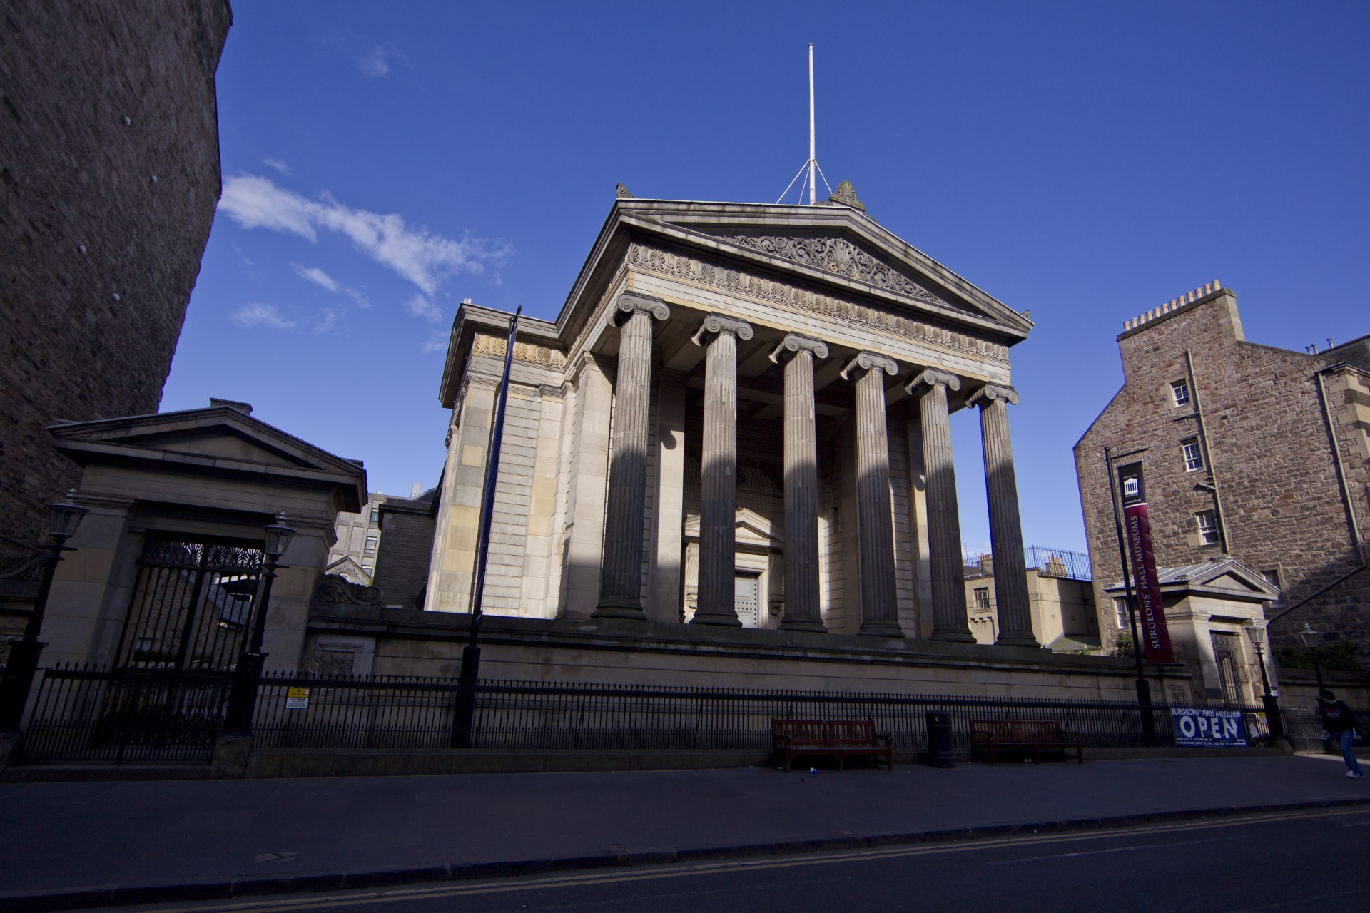
  - Issue 6 Winter 2023
sAVE THE DATE!!!
We are pleased to confirm the date of the 45th Scientific Meeting will be Thursday 6th June 2024 at Surgeon’s Hall, Edinburgh. Not only will there be the usual varied program of presentations but also a poster competition and exclusive access to the Surgeons Hall Museum. More details to follow in the New Year.
Modern rotary microtome

Welcome Delegates and fellow Science enthusiasts,
welcome all to the festive Association of Histotechnology (SAH) newsletter! Unbelievably we’re already in the festive period - The Committee and I would like to extend warm Christmas Wishes and a Happy New Year too. Planning for our next event the 45th Scientific Meeting is underway and we have an exciting new venue to share with you.
Updating from our call for committee members last time, we would like to extend a warm and grateful welcome to new member Beth Gregor-Quinn. There are still positions available for anyone interested in joining the SAH Committee which includes named roles and support members. Please do email one of the Committee Members or the generic email address [sah.generic@lanarkshire.scot.nhs.uk] if you would like some more information.
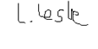
And with that, I would again like to thank you for your continued support and feedback which allows us to organise and host these events. We hope you all have a fantastic festive period and that you all come into the new year fresh and ready for some more Scientific magic.
Louise Leslie
Specialist Biomedical Scientist
Scottish Association of Histotechnology Committee Chair

The Dr Robert Knox Collection BY bETH gREGOR-qUINN
The Dr Robert Knox collection, based within the Surgeons Hall in Edinburgh, contains a variety of fascinating pathological and anatomical specimens. The collection includes a lymph node, vein and artery affected by tuberculosis, as well as many other interesting specimens. Dr Robert Knox (1791-1862) was a renowned anatomist and lecturer, and was involved in most aspects of the Surgeons Hall Museum and its set up during the 1820’s.
Dr Robert Knox began studying at the University of Edinburgh in 1810, where attended an Anatomy class, taken by Dr John Barclay. After graduating, Dr Knox joined the army in 1814 and was posted to Brussels, to attended to those injured in the Battle of Waterloo. On his return to Scotland in 1822, Dr Knox got involved with Dr Barclay’s anatomy school, where he became an assistant lecturer, published several scientific papers in the fields of anatomy and pathology, and was elected a Fellow of the Royal Society of Edinburgh in 1823. In 1824, Robert Knox submitted a proposal for a museum based on Dr Barclay’s collection of anatomical specimens. The proposal was accepted in 1825, and Dr Knox became the Museum Conservator, a Fellow of the College and was given joint charge of the museum, alongside Dr Barclay.
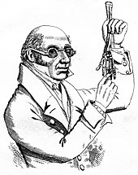
When Dr Barclay died in 1826, Dr Knox was left in charge of the museum and anatomy school, where he became a renowned lecturer, known for his classes in which students could see the complete dissection of a human body. Such classes required a supply of human bodies for dissection. It was this need for bodies which led Dr Knox to his involuntary involvement in the Burke and Hare murders in 1828. The 16 victims’ bodies were sold to Dr Knox’s anatomy school. There was no evidence to suggest that Dr Knox knew about the murders or had any involvement in them, however his reputation was ruined when the public found out that he had purchased the bodies.
In July 1831, Dr Knox resigned as conservator of the museum, shortly before the new Surgeons Hall was completed. In 1842, after failing to secure a new teaching position in Scotland, Dr Knox moved to London, and never returned. After publishing several books in London, Dr Knox died in 1862. The Knox and Barclay collections are still housed within the Surgeons Hall Museum in Edinburgh and are available for the public to view.
References:
Key collection page (2023) Surgeons Hall Museums News. Available at: https://museum.rcsed.ac.uk/the-collection/key-collections/key-collection-page?collID=1192 (Accessed: 01 December 2023).
Robert Knox (2023) The Royal College of Surgeons of Edinburgh. Available at: https://archiveandlibrary. rcsed.ac.uk/surgeon/3770389-robert-knox (Accessed: 01 December 2023).
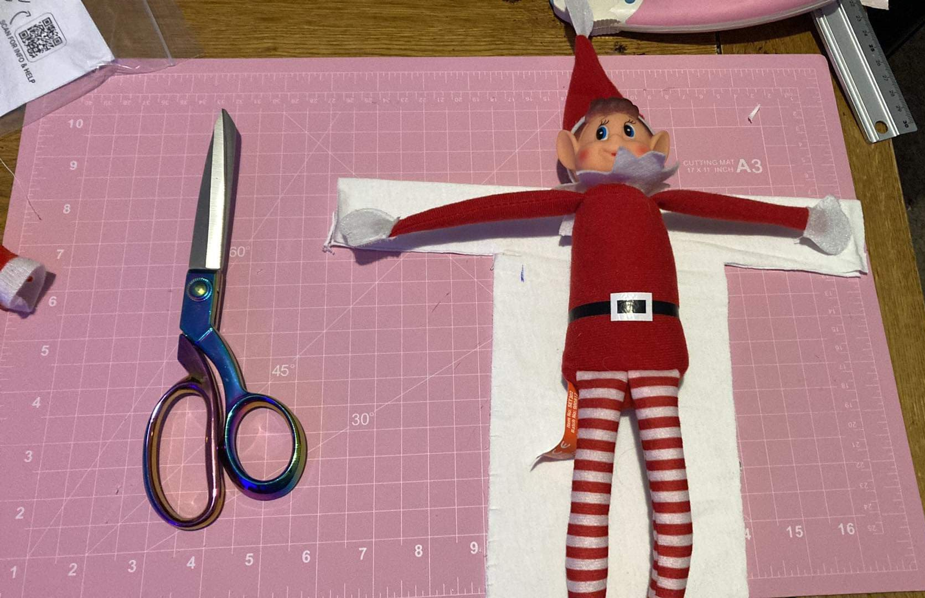
POSTER COMPETITION 2024
To make our next scientific meeting more involved,the SAH are running a poster comptetion.
These posters can be from any BSc/MSc project or other departmental research.
A panel of judges will make the decision and there is a cash prize of £50.
If you would like to enter a poster, please add the poster title on the meeting registration form, which will be circulated in the spring.
Puzzle corner - ANAGRAMS  - rematch starfish - hurl pod - markups - crackliest melvin - cher thing - boozer creesegene - cleaning skews - jocks rafts - jenn macloch - jacketing knolls  Clue: Festive characters (NB: Issue 5 answers on SAH website) | Contact us!!  Email: sah.generic@lanarkshire.scot.nhs.uk  Website: www.saht.org.uk  Twitter: @ScottishAssoci1  Instagram: scottishassociationhistotech  Facebook: @www.saht.org.uk
Recipient Name
Street Address
City, ST ZIP Code

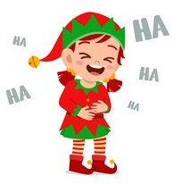
CHRISTMAS CRACKER
Q. What does an elf leave in the toilet?
A. Jingle smells!!

